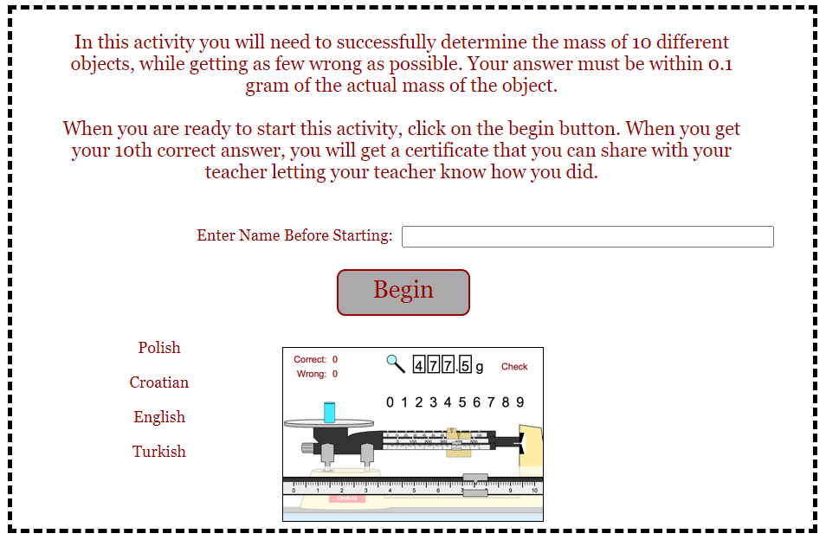
https://www.thephysicsaviary.com/Physics/Programs/Games/ReadtheTripleBeam/index.html

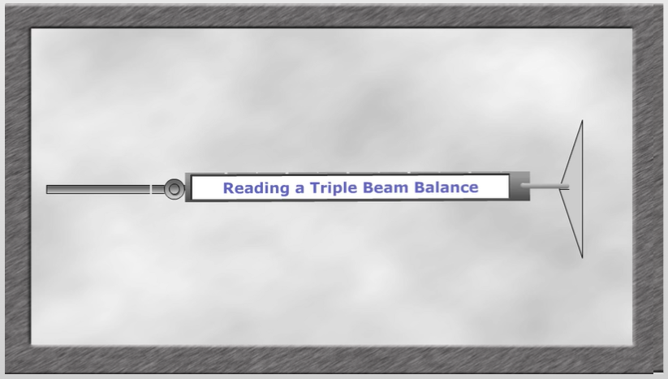
https://www.wisc-online.com/learn/natural-science/chemistry/gch202/reading-a-triple-beam-balance

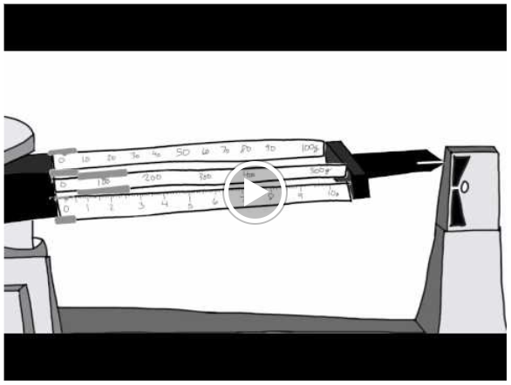
https://www.youtube.com/watch?v=stW-C7F7QOg&t=3s

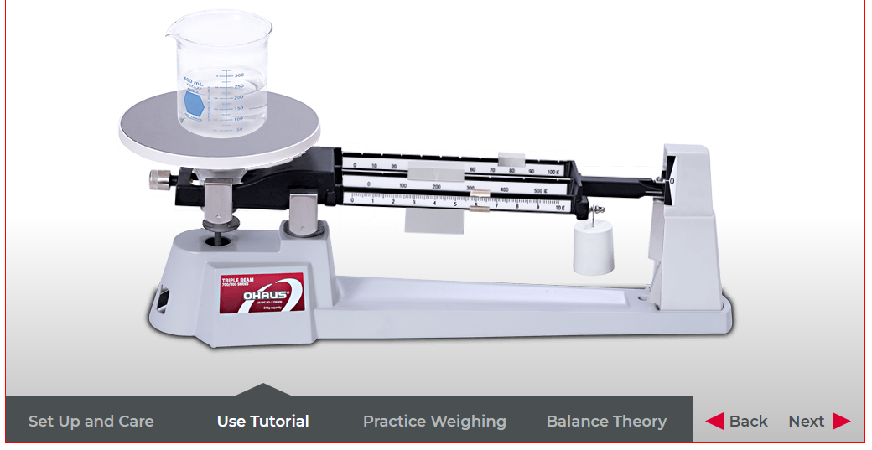
https://us.ohaus.com/en-us/tutorials/triple-beam

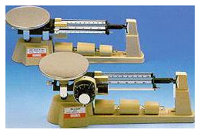
https://www.edinformatics.com/math_science/mass.htm

